# Lab 4: Your First Component

## Objectives

*  Create a component
*  Render the component

## Steps

### Create a component

1. **Create** the directory src\projects.
2. **Create** the file src\projects\ProjectsPage.js
3. In the file, **create** a **function** **component** that returns the following html:

<h1>Projects</h1>

The solution code for the component appears next. Challenge yourself to write it from scratch before looking at it.

In VS Code, you could use this extension [VS Code ES7 React/Redux/React-Native/JS snippets](https://marketplace.visualstudio.com/items?itemName=dsznajder.es7-react-js-snippets" \t "https://handsonreact.com/docs/labs/js/_blank) that you installed as part of the setup for the course and then type rfce then tab.

### Solution

#### src\projects\ProjectsPage.js

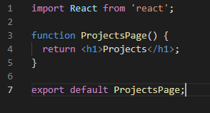

The import: import React from 'react'; is not required in the latest version(s) of **React** because it uses a new JSX Transform.

* React 17 RC and **higher** supports the new JSX Transform, and they’ve also released React 16.14.0, React 15.7.0, and React 0.14.10 for people who are still on the older major versions).
* With the new JSX Transform, the import statement is only needed at the entry point of the application which is src\index.js in a **Create React App**. Note that the code still works if you include the import in other files but it is no longer required.
* The import is included throughout the labs so the code continues to work on older versions of React

### Render the component

1. **Remove** the <blockquote>...</blockquote> we returned in the last lab and **replace** it with <ProjectsPage/> wrapped in a div with a css class of container.

#### src\App.js

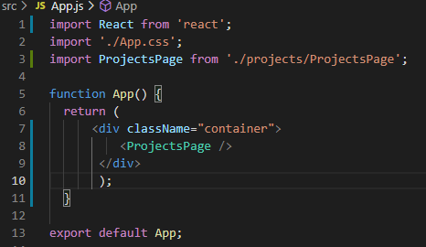

1. **Verify** the following is displayed in the browser:

**Projects**

### ✔ You have completed Lab 4